**React Hooks**

Set of small project about React Hooks

1. **page “Holidays”** for the financial project in the company, it contains: a table of all holidays for a particular year to be chosen by the user (input select), and the table contains two buttons edit and delete the data.

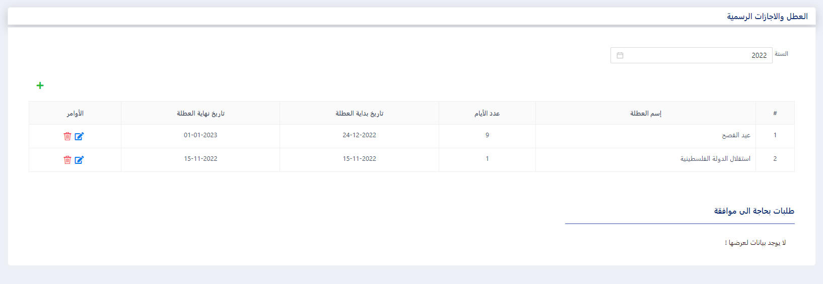**Select Year**

**Add Holidays**

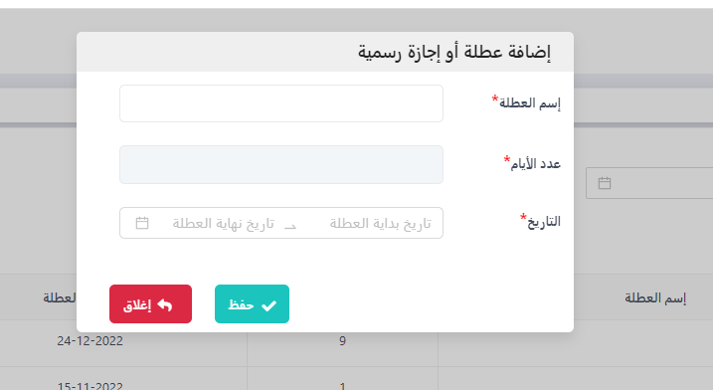

**Edit Holidays**

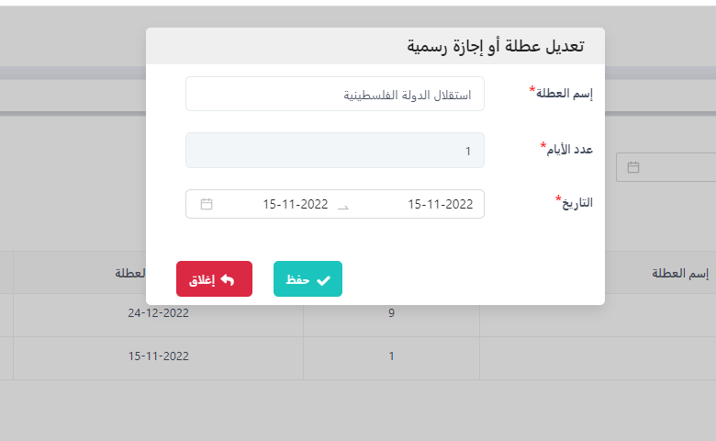

**Delete Holidays**

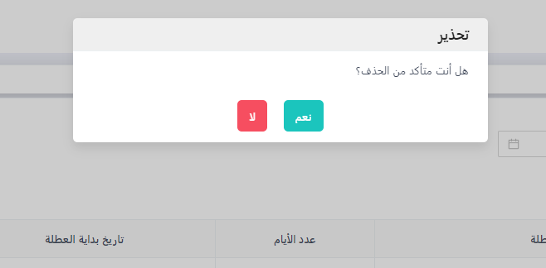

1. **Page “Employees”,** it contains input search enables the user to search an employee from a table, and the table contains two button (edit and remove the data), also using JQuery.

**Home Emplyee**

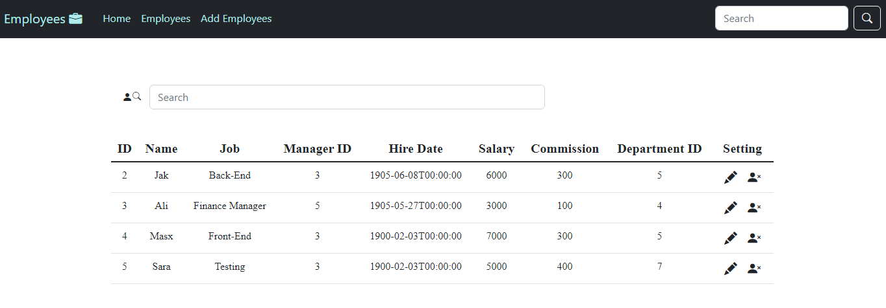

Search Employee

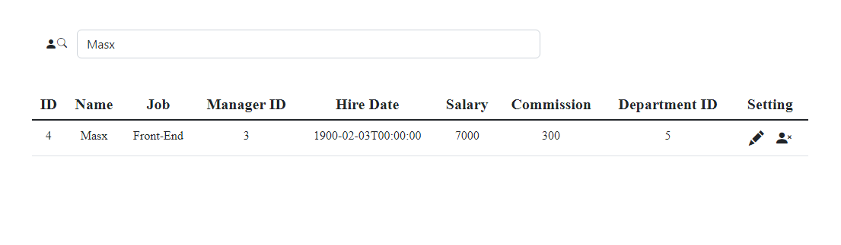

Edit Employee

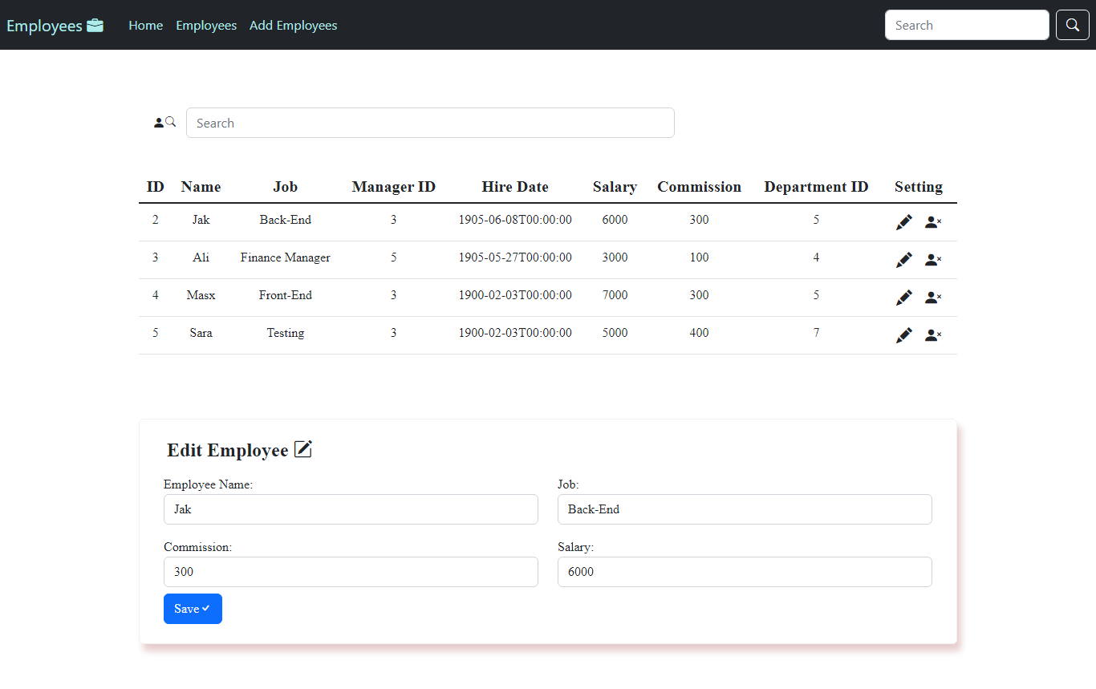

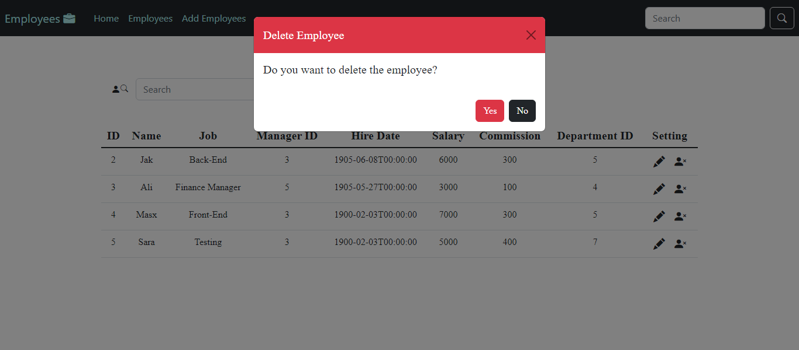Delete Employee